APPLICATION OF DOROTHEA OREM'S SELF-CARE DEFICIT THEORY IN MANAGING PATIENT'S USING INSULIN INJECTION.

Orem’s Theory.
Dorothy Orem defines self-care as actions that people can launch willingly to make sure that the quality of life is advanced by ensuring effective psychological, mental, physical, and social health
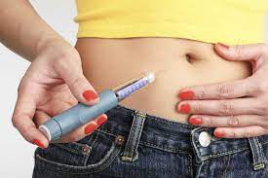

Importance of Orem’s theory.
it helps patients learn that they can recover faster and efficiently if they take control of their health.

Diabetes Type 2.
Diabetes mellitus type-2 (2 DM) is a chronic disease relating to type-1 diabetes. That typically occurs when the body resists insulin or cannot produce enough insulin prohibiting the body from processing sugars. Dunphy el. at., 2019 defines it as the abnormal secretion of insulin, resistance to the action of insulin in the target tissues, or the inadequate response at the insulin receptor level. For a patient with BS of above 200, the best solution is to maintain the blood sugar level by administration of insulin.
Importance of insulin self-care
- Avoids frequent visits to the ER.
- To learn an effective way of insulin administration
- To improve quality of life.
Dependent care.
For patients that are dependent on other people to take care of them, the caretakers will undergo lessons on how to administer the insulin injections.
Nursing research.
Research by (Poudel et al, 2018) argues that Proper insulin injection practice is essential for better diabetic control

QSEN Competencies.
- Patient-centered care.
The program will provide compassionate and coordinated care based on respect for the patient’s preferences, values, and needs.

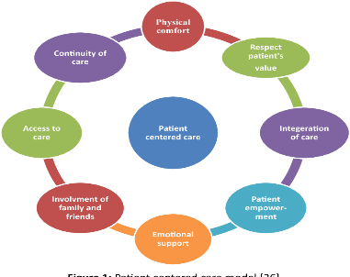
It will involve offering information, communication, and education regarding effective insulin administration.
- Teamwork.
The program will foster open communication, mutual respect, and shared decision-making to achieve quality patient care.
Teamwork ensures that adverse effects caused by miscommunication are avoided and that caretakers do not misunderstand their roles and responsibilities.

- Evidence-based programs.
The program will consider the preferences of the patient by looking at evidence of previous care.
Evidence shows that a patient should visit a doctor two to four times a year, avoid smoking, frequent exercising, and visiting an eye and foot doctor at least once a year.

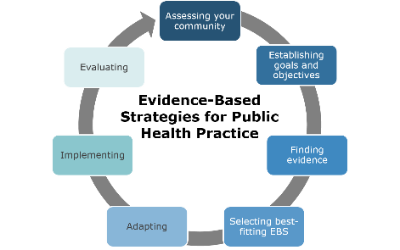
- Quality management.
The program will ensure that patients are their caretakers are familiar with strategies for administering quality injections.
Quality management will ensure that effective processes are utilized to monitor, assess, and improve the quality o insulin injections.



- Safety
The program will keep the patient and staff free from harm and minimize errors in care.
Before the injection, the label should be verified to ensure that the wrong dosage is not administered.
A patient must pinch a piece of the skin in the stomach area to administer the insulin injection.
Administration units are based on the size of the syringe.

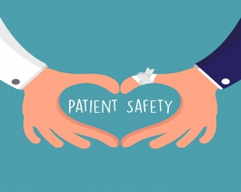
- Informatics
The use of HER will ensure access and use of information and electronic tech to communicate, manage knowledge, prevent error, and support decision making.
Information concerning diabetes and insulin injection can be found on the Center for Diseases Control (CDC) website.


Conclusion.
This self-care education will not only help the patients facing diabetes but also those living with them.
QSEN competencies will ensure that Orem's theory application of self-care is utilized.
That is, a patient can take care of themselves as studied by Orem theory.


Reference.
Poudel, R. S., Shrestha, S., Piryani, R. M., Basyal, B., Kaucha, K., & Adhikari, S. (2017). Assessment of insulin injection practice among diabetes patients in a tertiary healthcare center in Nepal: a preliminary study. Journal of diabetes research, 2017.

Fighting diabetes can save lives.
THANK YOU

